Ageing
well in a
changing
world
by the Commissioner
for Senior Victorians
SUMMARY REPORT

Department of Health
Ageing
well in a
changing
world
by the Commissioner
for Senior Victorians
SUMMARY REPORT

To receive this publication in an accessible format phone +61 3 9096 7542 (metro) or mobile phone number 1300 253 942 (regional), using the National Relay Service 13 36 77 if required, or email the Commissioner for Senior Victorians <CommissionerForSeniorVics@dhhs.vic.gov.au>
Editor: Kate Robertson, Icebreaker Communications. Designer: Narelle Sullivan. Photographer: Nicole Cleary Photography (Rosie Finn AO, John and Chisal), Katrina Lawrence Photography (Souria Yousef).
Authorised and published by the Victorian Government, 1 Treasury Place, Melbourne.
© State of Victoria, Australia, Commissioner for Senior Victorians, October 2020 (2003670)
Except where otherwise indicated, the images in this publication show models and illustrative settings only, and do not necessarily depict actual services, facilities or recipients of services.
ISBN 978-1-76096-169-5 (Print)
ISBN 978-1-76096-170-1 (pdf/online/MS word)
Available at Commissioner for Senior Victorians <http://www.seniorsonline.vic.gov.au/commissioner>

Contents
Introduction 6
1. Priority action areas 8
1. Senior Victorians desire to have a greater voice 8
2. Triggering a longevity dividend 8
3. Respect and recognition of older people 8
4. Navigation to services and support 8
5. Online alternatives and support 9
2. Victoria’s ageing population 10
2.1 Life expectancy and the phases of ageing 10
2.2 Living independently for longer 11
3. The research 12
3.1 Overall wellbeing and quality of life 12
3.2 Social wellbeing 12
3.3 Summary of priorities for health, social wellbeing and independence 12
3.4 Isolation and loneliness 13
3.5 Factors reducing quality of life 13
4. Attributes of ageing well 15
4.1 Having a positive attitude 15
4.2 Have purpose and meaning 16
4.3 Be respected and respectful 16
4.4 Be connected to family, friends and society 17
4.5 Stay in touch with a changing world 17
4.6 Be safe and secure at home and financially 18
4.7 Be able to manage health issues including mental health 18
4.8 Be able to get around 19
5. Opportunities to improve the experience of ageing 20
Addendum 22

Introduction
This summary report is an abbreviated version of the Ageing Well in a Changing World report, which presents an overview of feedback obtained from senior Victorians about their thoughts on what it means to ‘age well’.
The Victorian Department of Health and Human Services commissioned the report in August 2019, to inform the development of its Ageing Well framework (refer Appendix 1 of the main report). The framework aims to maximise the wellbeing and quality of life of older Victorians by supporting future policy development and assisting with determining funding priorities in the Ageing and Carers portfolios.
The Commissioner for Senior Victorians was asked to canvas the views of senior Victorians on ‘ageing well’ to ensure the framework is informed by their aspirations and real-life experiences. The Ageing Well in a Changing World report is the result of that research, which was completed in October 2019.
Life for all Victorians, old and young, has changed radically since that time, following the outbreak of the highly contagious coronavirus COVID-19 which was declared a pandemic by the World Health Organisation (WHO) on March 11, 2020.
Older people have been disproportionately impacted by the pandemic, with the overwhelming majority of deaths among people aged over 60, in particular those with co-morbidities. Senior Victorians have been particularly affected by the occurrence of a second wave of COVID-19 which caused a high death toll of residents in aged care. There was also a significant increase in risk of isolation and loneliness among older people due to stricter stay at home directions and restricted access of families to those living in aged care homes.
Our population is ageing. People over 85 years old are the fastest growing population group in Australia. Ensuring Victorians are supported to ‘age well’ must be a priority not just because it is the right thing to do for seniors and their loved ones, but because it is beneficial for our society overall. Older Victorians are willing and able to continue to contribute to society in a positive way. Fostering the conditions that enable them to age well will assist them to do so.
What does it mean to ‘age well’? The report talks to the experts – senior Victorians themselves – to hear their views not only on what ageing well means to them, but what barriers they face to achieving it and the opportunities available at all levels of society to facilitate ageing well.
For the foreseeable future, the aspiration for senior Victorians to ‘age well’, will occur in the context of COVID-19. Thus, the findings of this report take on even greater importance and provide a sound basis to inform the re-shaping of our health, economic, service and community systems to support our ageing population in the wake of the pandemic
It is a timely report; the World Health Organisation has declared 2020 to 2030 as the decade of healthy ageing, putting the spotlight on the need for individuals, governments and societies to make ageing well a priority.
[Break out box text:
‘The Decade of Healthy Ageing (2020–2030) is an opportunity to bring together governments, civil society, international agencies, professionals, academia, the media, and the private sector for ten years of concerted, catalytic and collaborative action to improve the lives of older people, their families, and the communities in which they live.’
End of break out box text.]
Thanks to all senior Victorians who generously gave their time to assist with this report, and who look forward to seeing its impact on policy development into the future.
Gerard Mansour
Commissioner for Senior Victorians

1. Priority action areas
Medical advances over the last 100 years have delivered unprecedented longevity in populations around the world. With many people living well into their 80s and 90s with a continuing desire to contribute to, and be recognised by, the world around them, there is a valuable social dividend to be gained from including older people in social and economic endeavours and leveraging their skills. The benefits are two-fold: communities benefit from older people’s ongoing contributions and individuals maximise their quality of life as they age.
However, the evidence from older people is that this opportunity can be undermined by negative ageist attitudes. Many feel that they are invisible in society and are excluded from services and opportunities to participate in their communities, which erodes their rights and contributes to physical and mental ill health.
Much can be done at the government and service system level, with older Victorians identifying five initial priority areas for action at the State Government level, namely:

1. Senior Victorians desire to have a greater voice
Older people want to have greater input into factors that impact on their wellbeing and ability to age well. They have the knowledge, wisdom and expertise to contribute to policy discussions and the setting of priorities, including through the WHO Decade of Healthy Ageing. Governments and communities will benefit from giving older people a voice in decision making.
In progressing the Ageing Well framework, the Victorian Government could give consideration to this by, for example, appointing an advisory group of older people. A Victorian ‘State of ageing’ report should be published, for example, every three years to provide an update on the progress made on the Ageing Well framework to ensure their input is being acted upon.

2. Triggering a longevity dividend
Maximising the participation of older people in social, economic and community life will deliver long-term dividends for our society as the population continues to age. This will require investing in resources to enable older people to age well in their local communities and pursue activities that engage and interest them.
It will include supporting better self-management of health, enabling economic and workforce participation, increasing access to secure and appropriate housing, and maintaining the Seniors and Carers card discount programs, the Seniors myki and government concessions.

3. Respect and recognition of older people
Older people reported facing ageism, including a feeling that society treats them as if they are invisible, rather than valuing their contribution. This should be addressed by fostering respect for seniors and reinforcing their right to be treated with dignity as they age, have independence in decision making, and to live free from harm and abuse. Strategies are needed to reduce internalised ageism and the stigma associated with seeking help that cause older people to delay getting necessary services and support.
It includes fostering social connections to reduce isolation and loneliness, including within residential aged care settings, through a range of initiatives such as strengthening community connections and expanding intergenerational programs.

4. Navigation to services and support
To maintain their independence, older people need access to support and services in a timely manner. For example, there is need for greater recognition that mental health issues are not a natural consequence of growing old and that older people experiencing mental health issues should have access to and receive services tailored to meet their needs. In addition, older people report the aged care system is too complex and difficult to navigate and there are long waiting periods for home support services. They also struggle to identify the services they are eligible to receive.
Improvements are needed to ensure senior Victorians can readily find information and practical support, and that service systems are easily navigable so they can find the support they require. Better coordination of policies and services is needed to streamline access and delivery across all levels of government. This includes increasing the availability of local parking and community transport options to improve accessibility for older people to attend to necessities such as shopping, doctor appointments and chemist visits and to participate in local activities.

5. Online alternatives and support
Victorian seniors consider keeping in touch with our changing world to be a priority but, while some are comfortable using technology, many others require additional support to take advantage of online access to medical consultations and essential services as well as using the internet to maintain social connections. This requires strategies to address the digital divide as well as the provision of face-to-face or personalised alternatives to online platforms to access information, services and support.

Maximising quality of life
In terms of their opportunities for ageing well, older people were very clear that there are many things they can, and should, do for themselves to maximise their quality of life as they age. These include adopting a positive attitude to the experience of growing older, coming to terms with the challenges and limitations that arise and, as far as possible, self-managing their health and wellbeing.
However, they also recognise that their ability to age well is also impacted by external factors, such as economic and social conditions, community attitudes and access to services or support when needed.

2. Victoria’s ageing population
The Victorian population is continuing to age. Current generations of older people are living longer on average than prior generations and this trend is expected to continue. The number of people aged 65 years and over is predicted to almost triple by 2051. Those aged over 85 years are the fastest growing population group in Australia.
Figure 1 shows predicted population growth rates of people aged 60 to 74, and 75 and over.
Figure 1: Victorian population aged over 60 – predicted growth 2016–2056
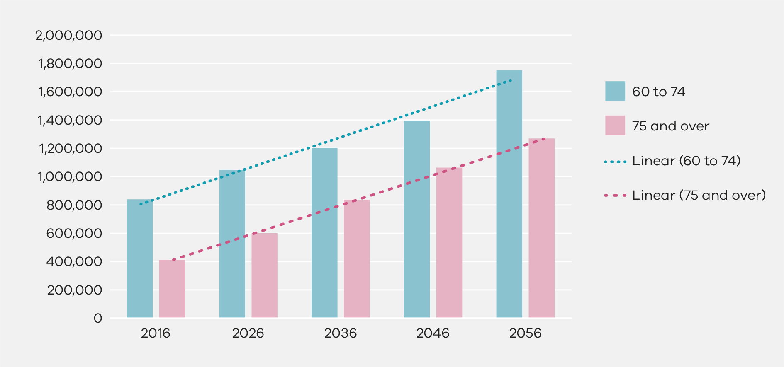

2.1 Life expectancy and the phases of ageing
The Victorian Population Health Survey 2017 shows the life expectancy for those aged 60 years and over continues to increase. Those who reach 60 years of age in 2016–18 can expect to live:
- an additional 24.5 years, if male
  - an additional 27.2 years, if female.
This means that those who reach 60 years of age will, on average, still have nearly a third of their lives left to live; a period of life longer than their childhood and teenage years combined. The capacity of individuals to age well is influenced by prior life experiences and social and economic factors. Many reach their 60s in very good health, while others may have chronic health conditions, a disability, or other challenges such as poverty or language barriers.
The Australian Institute of Health and Welfare (AIHW) provides a very useful outline of ‘life expectancy’ in terms of people’s health and wellbeing, their quality of life and functional status. The AIHW defines three phases of life after 65 years of age:
- Phase 1: Without disability – approximately 10 years of relative wellness, good health and physical activity.
  - Phase 2: With disability but no severe or profound core activity limitation – the next six to seven years sees individuals dealing with more complex needs but not severe or profound core limitations to their capacity.
Phase 3: With severe or profound core activity limitation – an additional three to five years, on average, characterised by higher levels of disability or frailty.
The AIHW concludes:
[Pull out quote:
‘… both sexes gained more years living free of disability and free of severe or profound core activity limitation than with it, indicating that the disability-free life expectancy of Australians has improved.’
End of pull out quote.]
The evidence suggests that many older people have a significant opportunity to age well, provided their health challenges can be effectively managed as these arise in later life.
One of the most important benefits of the ageing of our population is the increasing number of people who can retain high levels of wellbeing, activity and independence well into their 80s and beyond. This has enormous potential to increase social and economic capital, as well as enhance individual wellbeing and quality of life.

2.2 Living independently for longer
One of the most deeply held desires of older people is to remain in their homes and in their communities for as long as possible as they age.
[Pull out quote:
‘The survey data and other evidence of older people’s housing decisions unambiguously reveal that the majority of older people prefer to “age in place”. This does not necessarily mean never leaving the family home, although housing mobility does decline in old age. For many older people the “rubber band” attaching them to the family home is the desire to remain in the local community.’
End of pull out quote.]

3. The research
The research used a two-pronged approach to seek feedback from older Victorians; 4,726 seniors responded to an online survey, adding their voices to the views of the 231 people who took part in face-to-face consultations that were held across the state. The methodology is outlined at Appendix 2 of the full report and the survey questions are at Appendix 3 of the full report.

3.1 Overall wellbeing and quality of life
While seven in 10 respondents indicated some level of satisfaction with the quality of their life as they age, detailed feedback showed that a significant minority of older people experience limitations to their wellbeing. In particular:
- 42 per cent can only think about the future with a lot or some concern
- 41 per cent feel lonely often or some of the time
- 22 per cent have none or little of the enjoyment and pleasure they want
- 21 per cent have none or little of the love or friendship that they want
- 21 per cent have none or little of the things that make them feel valued
  - 5 per cent are not able to be independent at all or only in a few things.
Clearly, there is the potential to make major inroads into improving the health and wellbeing of older people by tackling these limitations, with a particular focus on fostering a positive mindset towards their future, increasing opportunities for social interaction and participating in things that make them feel valued and give them pleasure.

3.2 Social wellbeing
Respondents were asked to rate eight factors identified from international research as being important to your social wellbeing as you age. Their rankings for ‘highly important’ were:
- personal mobility – 92 per cent
- exercising independence in decision making – 83 per cent
- having meaning and purpose in life – 79 per cent
- social interactions with friends and/or family – 73 per cent
- having a hobby and/or regular recreation – 64 per cent
- access to learning opportunities, for example, U3A, libraries – 42 per cent
- participating in a club, group or organisation– 34 per cent
- volunteering, for example, with a community group, charity – 24 per cent.

3.3 Summary of priorities for health, social wellbeing and independence
The responses to the questionnaire at Table 1 show more than 73 per cent of all respondents ranked the following nine factors as being ‘highly important’ to their ability to age well.
Table 1: Highest rated priorities for health, social wellbeing and independence
Priorities for health, social wellbeing and independence | Highly important rating (%)
Having secure housing or accommodation | 97
Personal mobility | 92
Feeling safe in the community | 90
Self-management of my health | 88
Adequate financial resources | 86
Independence in decision making | 83
Access to good services and support when needed | 82
Having a meaning and purpose to life | 79
Social interactions with friends and/or family | 73
From survey responses, it is evident there are a wide range of factors that influence older people’s health, social wellbeing and independence. The nine factors in the table above provide a guide to the factors that are considered by the vast majority of respondents to be of most importance.

3.4 Isolation and loneliness
When surveyed about how often they feel lonely, 41 per cent said they feel lonely often or some of the time, and 21 per cent said they have none or little of the love or friendship that they want. There is significant evidence that the combination of social isolation and loneliness can have detrimental health outcomes, can undermine self-worth and lead to lower levels of wellbeing. Research has identified that the magnitude of the impact of isolation can be benchmarked against well-established risk factors:
[Pull out quote:
“Lacking social connections carries a risk that is comparable, and in many cases, exceeds that of other well accepted risk factors, including smoking up to 15 cigarettes per day, obesity, physical inactivity and air pollution.”
End of pull out quote.]

3.5 Factors reducing quality of life
Respondents were also asked to identify the most important factors reducing their quality of life from 16 factors that had been identified from international research. They then had to rate each of the factors on a four-point scale. The results are listed in Table 2 below.
Table 2: Highest rated factors that reduce quality of life
Priorities for Health, Social Wellbeing and Independence | Proportion of respondents (%)
Cost/affordability of activities/living expenses | 43
Lack of local opportunities that meet my interests | 36
Lack of information on what’s available in my community | 35
Lack of adequate and convenient parking at facilities in my community | 34
Being unprepared for life changing events | 29
Experiencing ageism, lack of respect | 28
Feeling unsafe when out in the community | 28
However, the most significant negative influence on an older person’s life is financial insecurity. This is understandable as it impacts not only on their day-to-day life, but also on their capacity to participate in paid social activities, events or interests. Programs that provide concessions and discounts, including the Victorian Seniors Card program, play an important role in reducing financial barriers for older people.

4. Attributes of ageing well
The combined feedback from the community consultations and the online survey provide a high-level overview of the ageing well aspirations of older people and have made it possible to identify the eight key attributes of ageing well from the perspective of an older person.
Diagram 1: Attributes of ageing well (see Addendum for a summary of the eight attibutes)
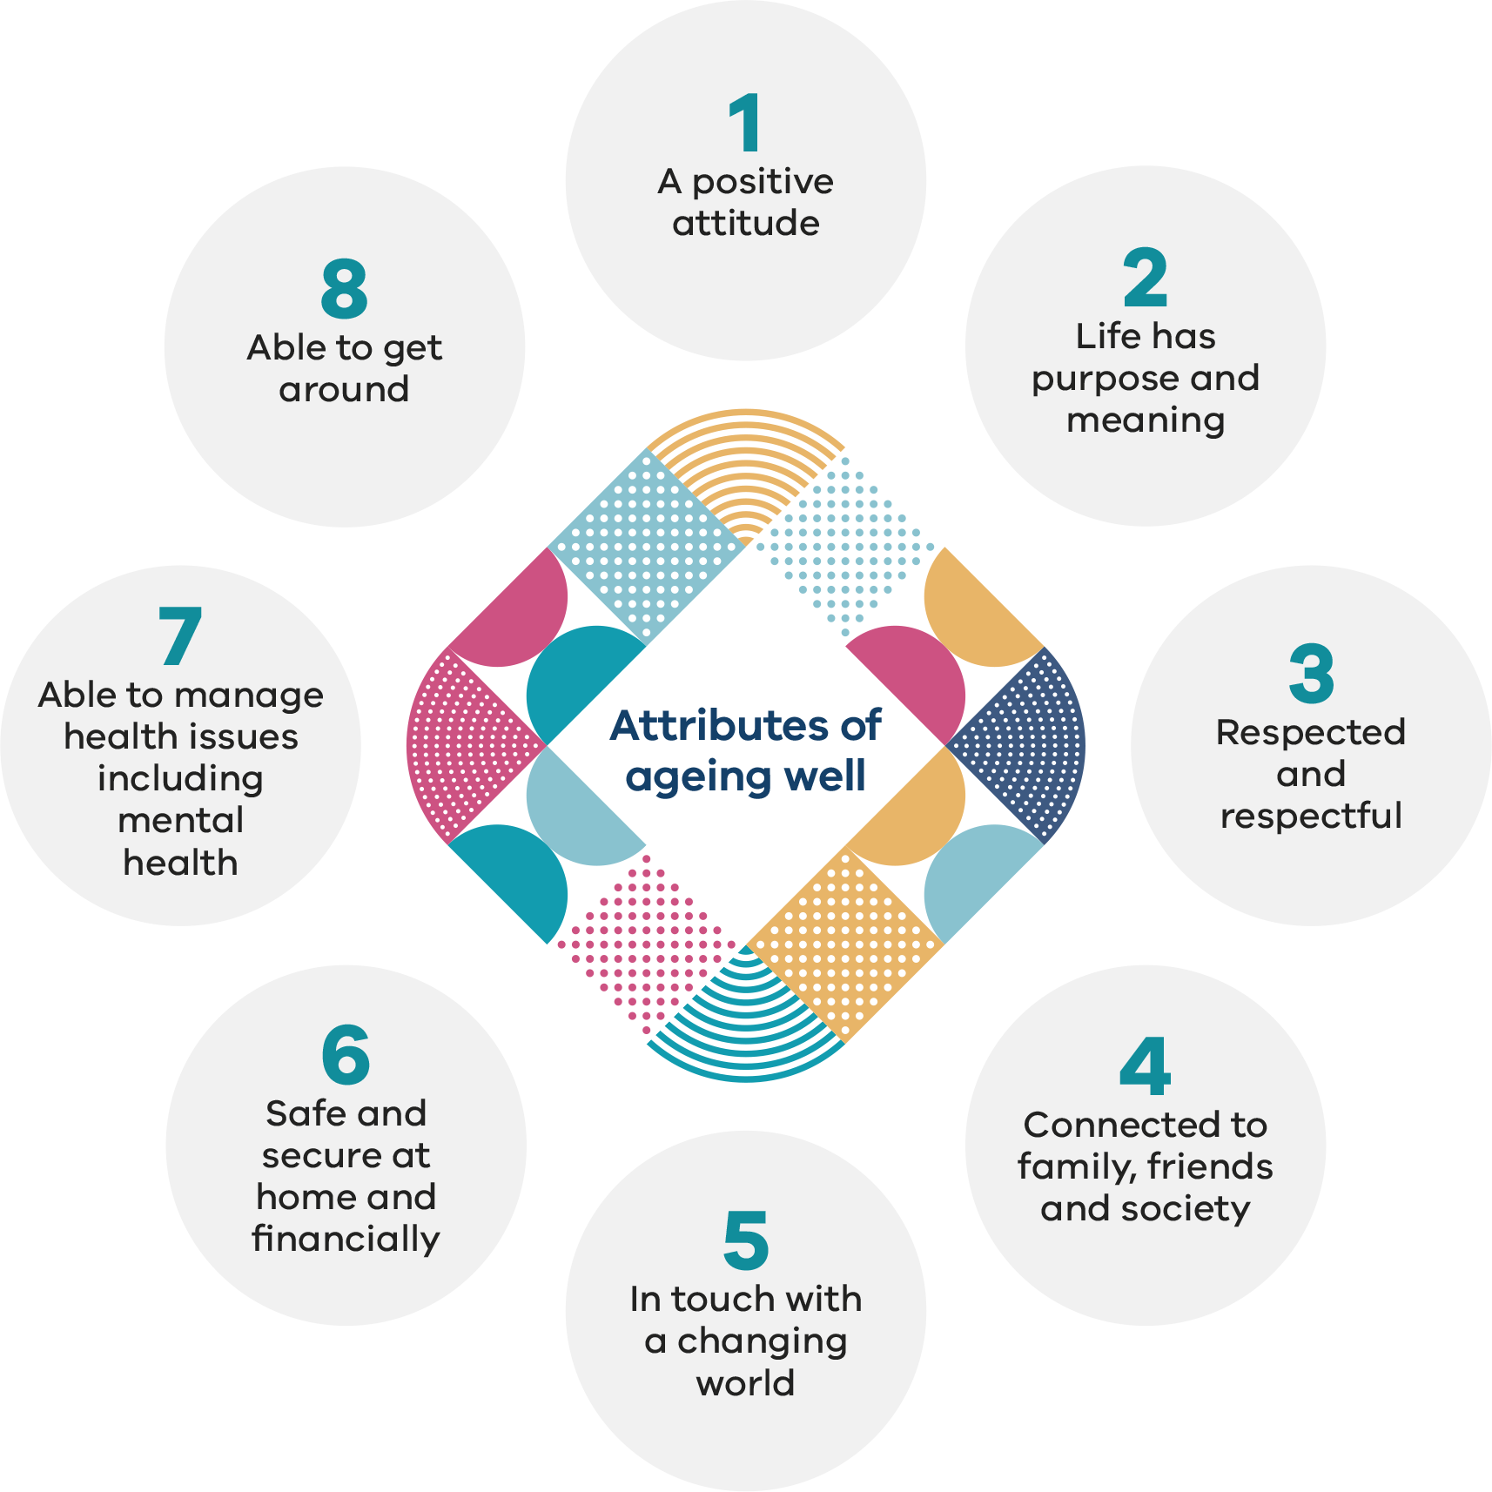
These attributes provide a sound starting point for developing policy and funding priorities relating to seniors and are a timely reminder of the need to embed regular consultation and feedback from older people on issues that impact upon them. See the Addendum for a summary of each of the attributes.

4.1 Having a positive attitude
[Pull out quote:
‘You need to have a positive attitude to age well. But you need to have acceptance that you will need help one day.’
End of pull out quote.]
When it comes to ageing well, one of the strongest areas of feedback relates to the need for senior Victorians to have a positive attitude so they can enjoy life, whilst understanding they also need to plan for the challenges of growing older and be realistic about one’s limitations and be willing to ask for help or support as needs arise.

4.2 Have purpose and meaning
[Pull out quote:
‘Enjoy life. Get involved in your community, socialise with other people, join groups, get out and travel.’
End of pull out quote.]
As people move through their senior years, the things in life that motivate and inspire them may vary but having meaning and purpose remains central to their wellbeing, happiness and enjoyment of life. A sense that life is worth living and provides fulfilment is often linked to giving back to the community and family and includes having meaningful social roles and the opportunity to continue to participate in the workforce. Some older people want to continue in paid employment or prefer to run a small business rather than being forced into retirement.
Seniors want to be recognised by society as capable people who make significant contributions to our community. Older people spoke of the importance of staying visible to society in general and that being part of the community is essential to their physical, emotional and psychological health.
Maintaining a life with purpose and fulfilment can be challenging as people move through their senior years. There are very few roadmaps for transitioning from a life in the workforce or caring for family to meaningful roles outside of employment and family.
[Pull out text:
Rosie Finn OA – importance of work
Rosie Finn OA had a brief fling with retirement before returning to work part-time for a community program, managing 100 clients and volunteers.
Rosie, who is now in her 70s, retired at 65 after a lifetime in community development in Australia and overseas; including a stint as a dental nurse for the Air Force, where she earned an Australia Day award for her heroic actions during Cyclone Tracy.
However, 12 months into retirement, she returned to part-time work, having missed the mental stimulation and financial rewards it provides. Employers are missing out if they discount older workers, she says.
‘I think I have more to offer now than when I was younger.’
End of pull out text.]

4.3 Be respected and respectful
[Pull out quote:
‘Not being treated like an “old” person – life stage doesn’t define who you are.’
End of pull out quote.]
The importance of giving and receiving respect cannot be overstated. This starts with respect for what each person has to offer as they age. Older people are very keen to contribute to, and be part of, the broader community and share their ideas and experiences. They want to be consulted on matters that affect them, including by all levels of government, and to be able to advocate for themselves and each other. The sense of ‘respect’ includes aspects of identity, culture and diversity.
Older people spoke of the stigma associated with being older, often represented by negative presentations of ageing and general assumptions that older people lack capacity and capability. Many people expressed concern that their life experiences and skills are not appropriately acknowledged or respected in the community, the workforce or by governments.
There were numerous examples of ageism in play. Many related their experiences of being stigmatised as old and ‘having lost their marbles’, being overlooked in retail environments, being blamed for intergenerational inequality and fear of a blame game between generations.

4.4 Be connected to family, friends and society
[Pull out quote:
‘It’s important to socialise with other people, not just your children. If you stay at home, you just look at the brick walls.’
End of pull out quote.]
Older people spoke about the importance of being able to maintain strong and effective relationships, for example, keeping in contact with grandchildren even if they have moved interstate or overseas. People spoke of the strength of these intergenerational relationships ‘keeping you young’, and that ‘you don’t get perceived as being “old” if you remain active with them’.
Neighbourliness, and knowing your neighbours, is seen as being an opportunity to give back to the community and a way of feeling good that can lead to greater safety and wellbeing. People gave many examples of the benefits of belonging to organisations, such as a neighbourhood houses, community groups, service or sporting clubs, arts groups, Universities of the Third Age and Men’s Sheds. The loss of meaningful relationships and social networks leading to social isolation and loneliness was identified as among the most significant risks to ageing well.
[Pull out text:
John and Chisal – maintaining social connections
John Ilsley, 79, and Chisal Perera, 66, met at a Men’s Shed in Strathmore three years ago. John took Chisal under his wing and the pair are now making their own wooden models of the HMS Victory.
‘I’d say I enjoy the camaraderie with the guys just as much as I do working on projects,’ John says.
Chisal didn’t know how to use a drill when he joined the Men’s Shed.
‘I started to build my own things. I made toys and now I’m making a model of the HMS Victory, learning from John.
‘This place is somewhere you feel like coming to at every opportunity you get. The guys here are first class.’
End of pull out text.]

4.5 Stay in touch with a changing world
[Pull out quote:
‘Challenge of change and resistance to change. We need to work together to help people better understand what it means to grow older, to be assisted through change and be less fearful.’
End of pull out quote.]
Older people recognise the importance of keeping up with a changing world and adapting to change in enabling them to age well. This has a personal element of being able to effectively manage changes in their own lives and a societal element of being able to stay in touch with new ideas, technologies and services.
However, while at every consultation session there were people who regularly use and are comfortable with information technology, there were numerous others who have no engagement with it whatsoever. The latter face enormous challenges in obtaining the required skills and competency to do so. There was a palpable sense of risk that many older people are being left behind by new methods of information communication and service delivery.
With so many government services, utilities and private businesses using the internet as their main, and sometimes only point of contact, seniors regularly spoke of the expectation that everyone has access to information technology as a form of discrimination.

4.6 Be safe and secure at home and financially
[Pull out quote:
‘Not possible to access all services or needs due to financial limitations. Choice and access to services is sometimes reliant on having sufficient money.’
End of pull out quote.]
Older people consider financial security and secure housing and accommodation to be highly important in order to age well. This includes the need for suitable housing options so that they can remain in their local community if they need to change their housing, for example to downsize.
Financial limitations experienced by older people include costs of living, such as rent and utilities. Managing the cost of living on a fixed income can mean that little is left for social and community participation. There were various examples of older people’s participation in social support programs or lifestyle activities being limited due to financial constraints.
In this context, Seniors Card discounts, the Seniors myki, government concessions and subsidised services and participation opportunities are all of vital importance.

4.7 Be able to manage health issues including mental health
[Pull out quote:
‘Doing everything you can to maintain good health; healthy diet and access to health services when required.’
End of pull out quote.]
Older people recognise the importance of taking personal responsibility for their own health and wellbeing, and for end-of-life matters, which can be often difficult to face. The high level of interest in self-management of health can inform the design of health prevention approaches, for example, where risk factors are addressed through strategies such as immunisation against flu or shingles, and community education about healthy eating.
Older people spoke of the benefits of participating in physical activity and exercise groups to assist them to self-manage their health, including gym, dancing, walking groups, bowls, tai chi, yoga, dog walking and golf for physical health and, for mental wellbeing, activities like book and bridge clubs, libraries, cooking groups, computer courses, Men’s Sheds and Universities of the Third Age.
Some of the most compelling challenges older people spoke about were the difficulty of navigating support from the aged care system, the long waiting lists for home support packages and the difficulty of identifying what support was available. There is a fear that the aged care system is too impersonal, and brings with it a loss of decision-making control, where people lack the necessary autonomy and support to be able to continue to manage their own lives.

4.8 Be able to get around
[Pull out quote:
‘Access to transport. Be able to get to social clubs, events and appointments.’
End of pull out quote.]
The ability to maintain personal mobility and be able to access transport options are major enablers of social participation, health management and prevention of social isolation and loneliness. Safe transport options play a key role in enabling older people to meet and take advantage of social participation opportunities.
Community transport was identified as a vital form of affordable door-to-door transport for many vulnerable people, including some older people and people with disabilities. It enables users to get around their local communities, participate in life fulfilling activities, do shopping, visit chemists and attend essential appointments such as with doctors and other services.
Limited mobility, loss of a driver’s licence and not being able to drive carry financial and adaptability risks and risks related to relying on others. Lack of access to parking was identified as a significant practical barrier to older people.

5. Opportunities to improve the experience of ageing
It is important to acknowledge that people’s circumstances are less determined by age than by the changes they experience as they age. That is, people in their 90s can continue to be fundamentally healthy and active while some in their 60s experience significant disability.
Whilst older people are keen to contribute to society, be self-sufficient and to take responsibility for their own health and wellbeing and personal circumstances, like people of all ages, they can’t achieve these aspirations on their own. The journey of ageing requires concerted individual, community and social action over time.
Feedback from older people demonstrates there are excellent opportunities to strengthen the capacity for older people to ‘age well’ at each of the levels in the socio-ecological model, which will, on the one hand, maximise the benefits of longevity and, on the other, minimise the negative impact of vulnerability for those requiring more assistance as they age.
Priorities for enabling ageing well at an individual level, in addition to practicing healthy habits and lifestyles, include providing options for older people who want to contribute to, and have a say about, matters that effect their lives and their ability to age well. This could be through advisory groups, structured consultation, ambassadorial programs, or other participatory channels.
Being able to age well involves preparing for, and acting on, changes in life circumstances that occur either suddenly or over time. This can include access to life planning information, access to housing, affordable activities, social connections, being willing to act on and receive support, planning for declining mobility and increasing frailty, as well as recognition of personal values and identity.
[Pull out text:
Souria Youssef – joy of volunteering
Souria Youssef’s husband often finds her in the kitchen at one in the morning, cooking up to 120 meals for members of the Senior Citizens Group that she helped found.
Souria, now in her 70s, immigrated to Australia from Egypt in 1978 and has become a treasured volunteer in the Egyptian and broader communities in Melbourne’s south east.
Her extensive range of unpaid work has included checking on vulnerable people through the Community Visitors Scheme, being a community transport driver, and raising money to help establish an aged care facility.
‘You have no idea how much satisfaction I get from it,’ Souria says.
End of pull out text.]
At the interpersonal level, senior Victorians prioritise positive and fulfilling social connections during their later years. These include friends, family and social networks that support their decision making and facilitate conversations about important life planning decisions and future arrangements and preferences.
Older people without such relationships face a heightened risk of social isolation and loneliness, which can be exacerbated when changes occur in later life. Some older people face a far greater risk of elder abuse, including those who no longer have trusted people to support them as their needs change over time.
At the community level, older people want to be respected, with their considerable skills, experience and time availability utilised within their communities. Many older people find meaning and purpose in community-based activities in new life stages after raising families and entering retirement. They make a huge contribution to sustaining community-run volunteer organisations and supporting local communities, but often feel this contribution is neither recognised nor valued by society. They need age-friendly communities and organisations, local infrastructure, facilities and community transport, information on opportunities for social and community participation and volunteering, opportunities to engage in healthy and active ageing activities, support for volunteering, inter-generational and inter-group use of community facilities and innovative models of aged care and addressing the issue of loneliness within residential aged care homes.
At the governmental and service system level, people need additional support to address their lack of technology skills, socio economic disadvantage, limited family or friendship networks as well as cultural or identity challenges. Governments are well placed to respond to the feedback that older people need timely access to more information about ageing that supports the importance of planning ahead and encourages people to seek support as their needs change.
Seniors want the government to address ageism and promote the rights of older people to be treated with respect. This includes the link between ageism and the stigma many older people feel when confronted with the need to have support or care services. This leads to internalised ageism, fear of loss of independence and control and unnecessary delay in reaching out for assistance. Seniors desire support to better plan for later life, for training and other initiatives to upskill older people and to continue to enjoy the benefits of the Seniors Card, Seniors myki and concession programs. In addition, seniors want an expansion of social participation opportunities, recognition that mental health issues are not a normal part of the ageing process, improved community transport, better access to parking, increased awareness of elder abuse, an expansion of mature age employment opportunities, regular reporting to the Victorian community on the state of ageing in Victoria as well as advocacy to the Commonwealth for better income support and access to the aged care system.
At the societal level, older people are battling ageism. They believe ageism underlies their experiences of feeling invisible in society, being stigmatised as incapable or incompetent, and labelled as having little to offer society. Older people would like more recognition of their immense contribution of experience, capabilities and wisdom. Increasing the respect society affords to older people for who they are and what they contribute can be achieved by giving seniors a greater say in decisions that are made about them, and the ageing of our population, by all levels of government.
Note: You can read the full report at <http://www.seniorsonline.vic.gov.au/ageing-well>

Addendum
Eight key attributes of ageing well
- Having a positive attitude
- a positive attitude to ageing, enjoying life and having fun
- able to deal with life changes, such as loss and grief
- realistic expectations about abilities and limitations
- accepting that help with daily living may be needed one day
  - able to deal with a shrinking social circle as you age.
- Life has purpose and meaning
- find meaningful social roles and continue to contribute to society
- be recognised and acknowledged as capable and able to contribute
- be able to access employment, volunteering, lifelong learning and other opportunities
- have personal independence and autonomy in decision making
  - key wishes and aspirations for living are understood and acknowledged.
- Respected and respectful
- valued in society as a respected member of the community
- have a voice and the opportunity to be heard
- work together across the generations and within community
- tolerant of others and receive respect from others, including government, younger people and businesses
- not subject to ageism, stigmatised, ignored or denied services because you are old
  - respect for personal identity, culture, gender and diversity.
- Connected to family, friends and society
- have fulfilling and sustaining social connections and personal relationships
- able to participate in meaningful activities related to interests, including lifelong learning
- able to build good social networks, relationships and supports
- have places to meet and connect with other people
- able to meet with people from the same cultural backgrounds, as well as people from diverse backgrounds
- able to maintain family relationships and friendships
  - obtain support for risks such as elder abuse.
- In touch with a changing world
- not left behind in our changing world
- know what is available to assist as needs change and increase
- able to obtain information when needed
- have opportunities to develop technology skills and knowledge, and to access technology
  - provided with alternatives to online platforms for information and services.
- Safe and secure at home and financially
- have the right housing at the right time, in the right place
- able to age in place with the right supports, including for falls prevention
- able to supplement income through work
- able to afford accommodation and utilities costs
- have access to a wide range of discounts for seniors
- feel safe at home and in the community, including at night
- have the right support to manage family and relationship stress and prevent elder abuse
- able to access free and low cost local social participation activities
  - able to undertake life planning and have decisions respected and supported.
- Able to manage health issues including mental health
- able to take personal responsibility for healthy ageing and wellbeing
- able to access services and support when needed
- actively plan to manage health conditions
- exercise for both mind and body
- maintain good nutrition and a healthy diet
- have access to health, wellbeing and sporting facilities
- have the knowledge and information to access support and services, particularly mental health services
  - have health needs, including mental health needs, recognised and responded to.
- Able to get around
- have access to cost-effective local community transport services, particularly after giving up a driver’s licence
- have access to parking and safe carparks, including prioritised parking for seniors, carers and disability
  - be in a built environment that is age-friendly, for example, has pedestrian crossings and footpaths and accessible for those using walking aids.

Dr Hans Henri P. Kluge, WHO Regional Director for Europe: Statement – Older people are at highest risk from COVID-19, but all must act to prevent community spread, Copenhagen, Denmark, 2 April 2020.
ABC News article <https://www.abc.net.au/news/2020-04-05/coronavirus-is-a-disaster-for-lonely-older-australians/12114034>
World Health Organization 2020, Decade of Healthy Ageing 2020–2030. (Website)
State of Victoria Department of Environment, Land, Water and Planning (2019). Victoria in Future 2019.
Victorian Agency for Health Information: Selected indicators from the Victorian Population Health Survey 2017 for older Victorians (unpublished). NOTE: information comes from a PowerPoint presentation provided to the Commissioner on 20 February 2020.
Australian Institute of Health and Welfare: Life expectancy and disability in Australia, 2017.
ibid
Australian Productivity Commission, Housing Decisions for Older Australians, 2015, p. 5.
Holt-Lundstad et al, 2015
Cacioppo & Cacioppo, 2014
Holt-Lundstad et al, 2017

