Community Connector
Referral pathway

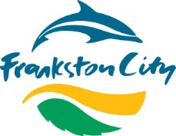

Community Connector Project advertised to Frankston and Mornington Peninsula Shire communities asking residents to call if they would like assistance connecting to a social activity.
Frankston residents/agencies call 9784 1046
- Resident/agency calls the number. Council Officer briefly explores what activities the community member is interested in.
- Council Officer requests permission from resident to provide telephone contact details to Community Connector.
- Council Officer calls suitable Community Connector and provides handover information regarding community members’ interest.
- Community Connector calls resident and listens to what activities they would like to join and provides activity suggestions or advises resident they will call back with activity suggestions if further research is required.
- If Community Connector is comfortable and the situation calls for it, the Community Connector can offer to buddy the resident to a new activity.
- Community Connector follows up with the community member one to two weeks post initial contact to discuss if the resident is still considering attending the activity or to provide further encouragement. Community Connector fills in appropriate paperwork.
- Community Connector completes Contact Form provided to them by Council Officer.
- Community Connector attends catch up with other volunteers and Council Officer to discuss challenges/opportunities.

